Purpose

The purpose for this circuit is to be a cheap alternative to burglary alarm systems. It uses very cheap parts like PIR Sensors, 555 timers, Piezos and capacitors that not only alerts if an intruder through a loud sound, but also will send a text message to your phone. There will be no monthly charge, just a one time price of around $100 if it were to be sold.

Function

It is supposed to detect heat signatures and movement through the PIR sensor . There is a delay created through a 555 timer and a capacitor to give users a cooldown. The PIR sensor once it detects movement, will send a signal to the Raspberry Pi which activities the script and texts the user that someone is there and also makes the Pi Camera takes a picture and also send the picture through email. It will also send a signal to a Piezo and make a sound. This process will repeat every minute.

Procedure

1. Setup Raspberry Pi
   1. Install operating system using SD card
   2. Input code to handle PIR Sensor Output
2. Setup PIR sensor on breadboard
   1. Put in LED
   2. Put in Piezo
   3. Connect power rails from second breadboard and connect respective resistors
   4. Hook up ground from Raspberry Pi
   5. Hook up batteries
3. Setup timer delay for alarm
   1. Get 3.3 V or 5V power and ground rail from Raspberry Pi
   2. Setup timer and resistors
   3. Hook up ‘armed’ LED
   4. Connect output to positive rail on primary breadboard
4. Program the code for the emailing and text messaging of intruder.
   1. Code the texting function that alerts users through text that someone is in the vicinity
   2. Obtain a Pi Camera and hook it up to the Raspberry Pi
   3. Code the part of the program that takes a picture using the Pi camera and emails users of the picture taken
   4. Combain the scripts
5. Add to script so that it ignores background voltage so that the script does not randomly turned on using ‘event_detect()’.

Parts List

|  |  |  |
| --- | --- | --- |
| Component | Number | Use |
| *PIR Sensor* | 1 | To identify the movement of objects around the vicinity and produce an output |
| *AA Batteries* | 3 | The power source for the project for testing |
| *Battery Holder *Capacity for 3 AA batteries with breadboard wires and pins* | 1 | To connect batteries to breadboard for testing |
| *Breadboard Piezo Buzzer* | 1 | Acts as the alarm |
| *Polarized Capacitor (100 uF, 16 V)* | 1 | Helps in creating delay |
| *555 timer* | 1 | Along with the capacitor brings the delay |
| *47 kilo ohm resistor* | 1 | Also to cause delay |
| *470 ohm resistor* | 1 | Also to cause delay |
| *Switch* | 2 | To control the circuit |
| *LED* | 3 | Lighting System |
| *Jumper Wires* | 20 -30 | Carry current through breadboard |
| *Breadboard* | 2 | Where all the parts are located |
| *Raspberry Pi Model 3 B* | 1 | *I will get this myself! |
| *Pi Camera* | 1 | Takes the picture that will be emailed to the user. |

How It Should Look

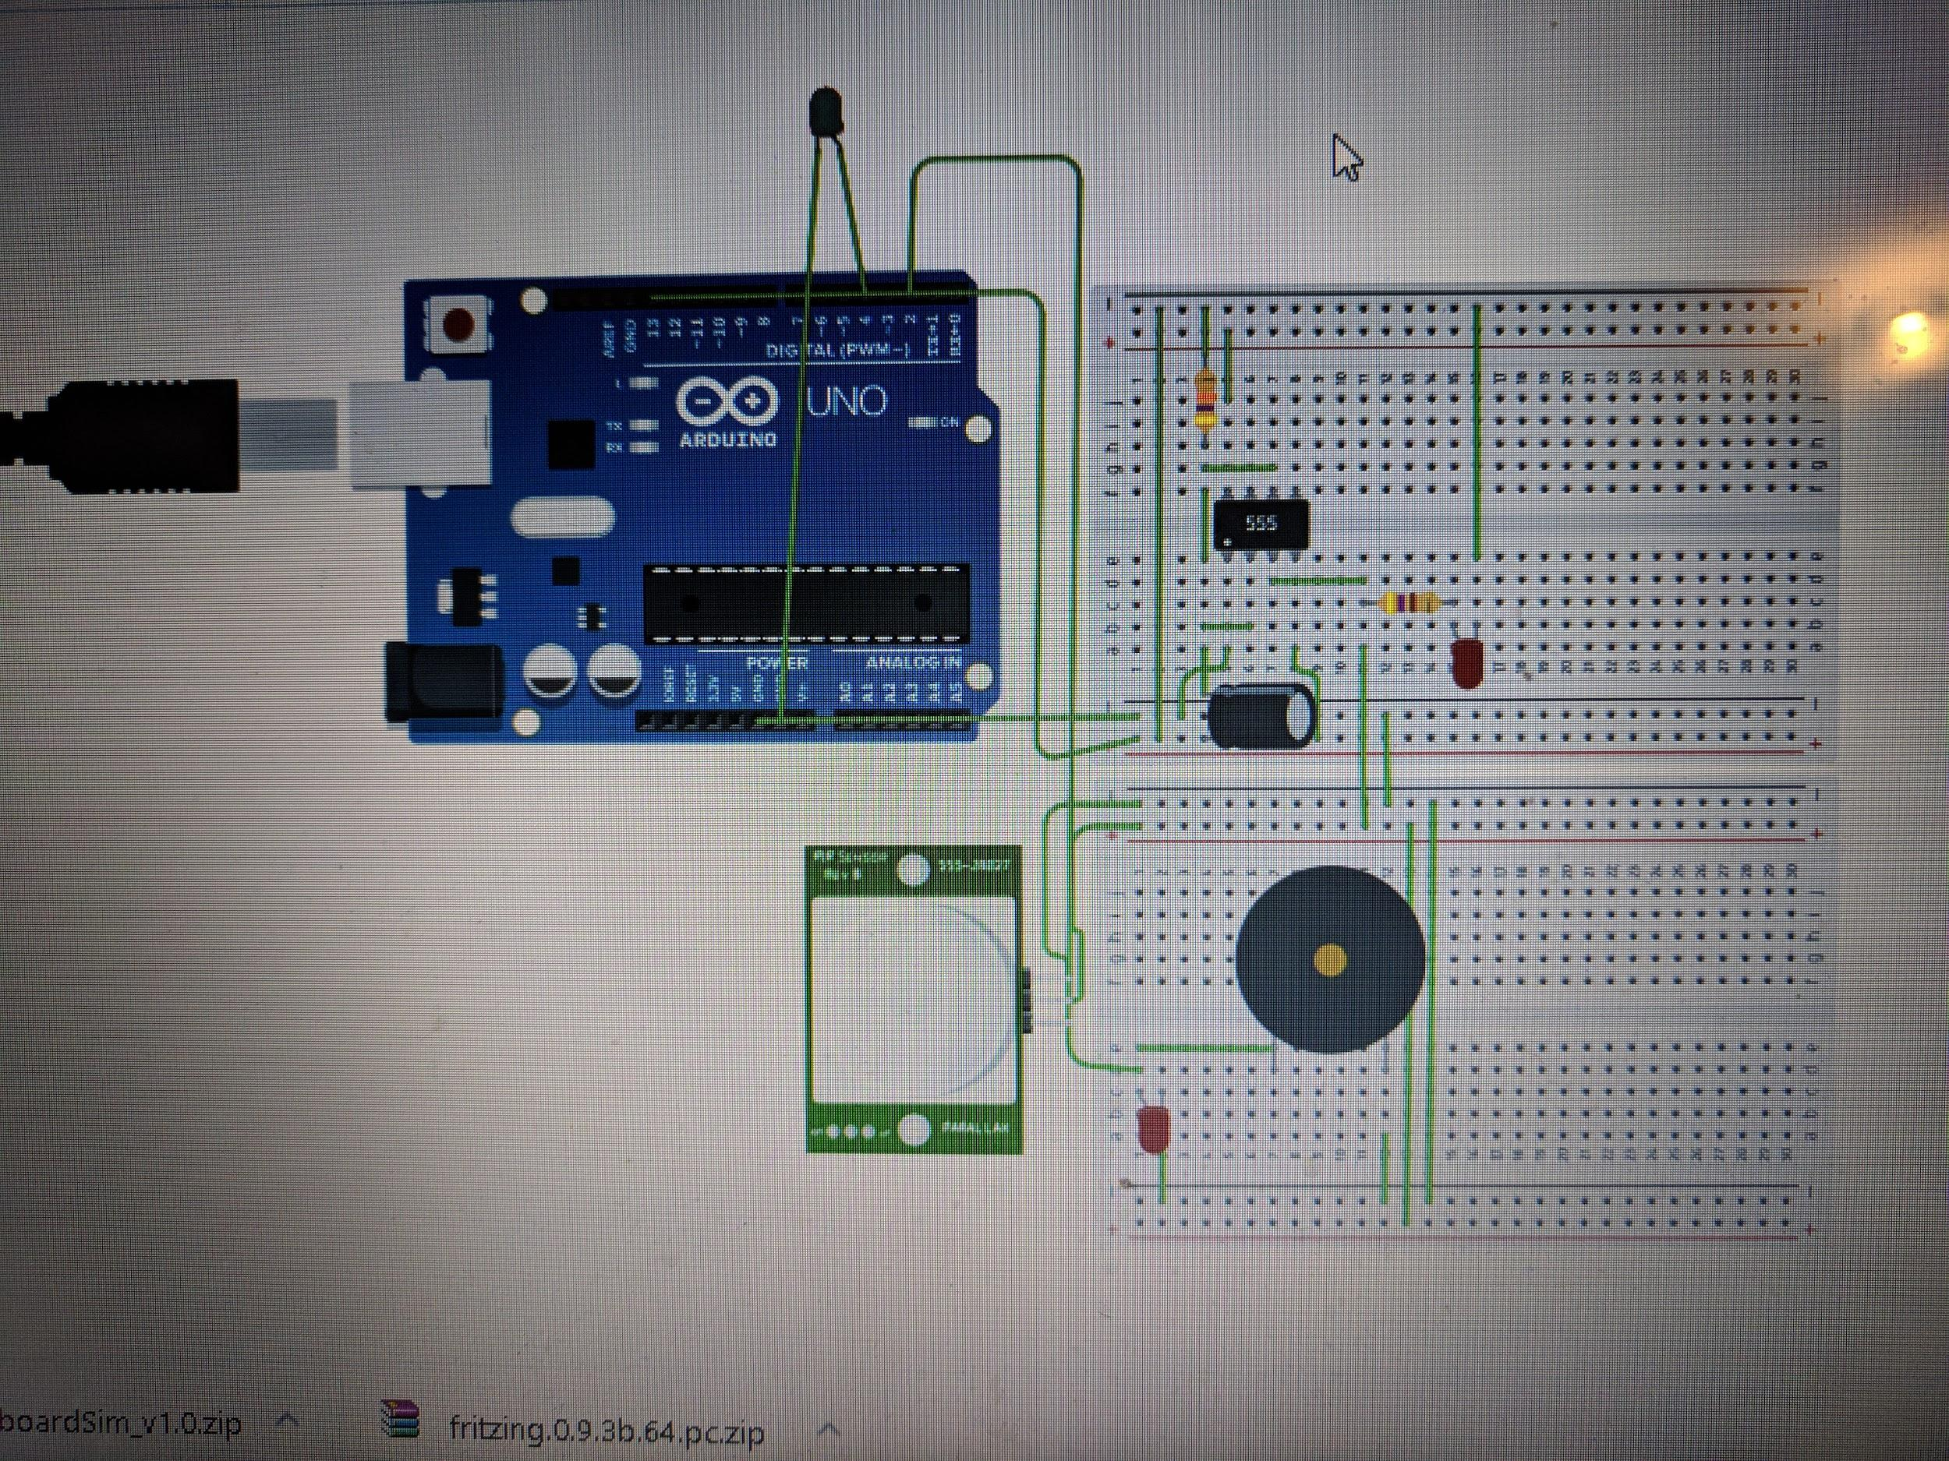

Issues I Faced

|  |  |
| --- | --- |
| Problem | Solution |
| Using the Raspberry Pi’s power rails became problematic because the 3.3V was a bit too much for the PIR sensor. Though resistors could be used, it was simpler to use an external power source | * Used 3 x 1.5V AA Batteries as Breadboard power source |
| Raspberry Pi would not boot, the operating system would not get burned onto the SD card | * It turns out the SD card was improper to the point where even reformatting it could not fix it, however, getting a new SD card seemed to work |
| Raspberry Pi camera was not working | * It turns out it was not plugged in correctly and a command ‘vcgencmd get_camera’ had to be used |
| Raspberry Pi was detecting random environmental voltage so it would run my script while not voltage was being outputted by my PIR sensor | * Within the script, instead, by checking for voltage dips, the script worked |

Future Plans

* I plan on making the design a little bit more simplified, perhaps by instead using a Pi Zero and a smaller breadboard. This way, by having it more compact it will be a lot easier to use.
* I also plan on making it so that the Piezo makes a much louder sound, this way it is easier for users to hear the sound
* I also plan on adding buttons/more user input to turn it on and off and help set a delay, this would make it more user friendly

Conclusion

I chose this project to create a device that would be an alternative to standard security systems, be cheaper than them, but also provide much more functionality. I have to say, this truly has been very successful, in terms of wiring, coding and the end product. Everything that I planned on implementing, especially the emails and text messages worked out in the end. There are a few things I wanted to add, including added simplicity. However, as a beginner project, it turned out pretty well.

Pi Security

*Security For Everyone!*

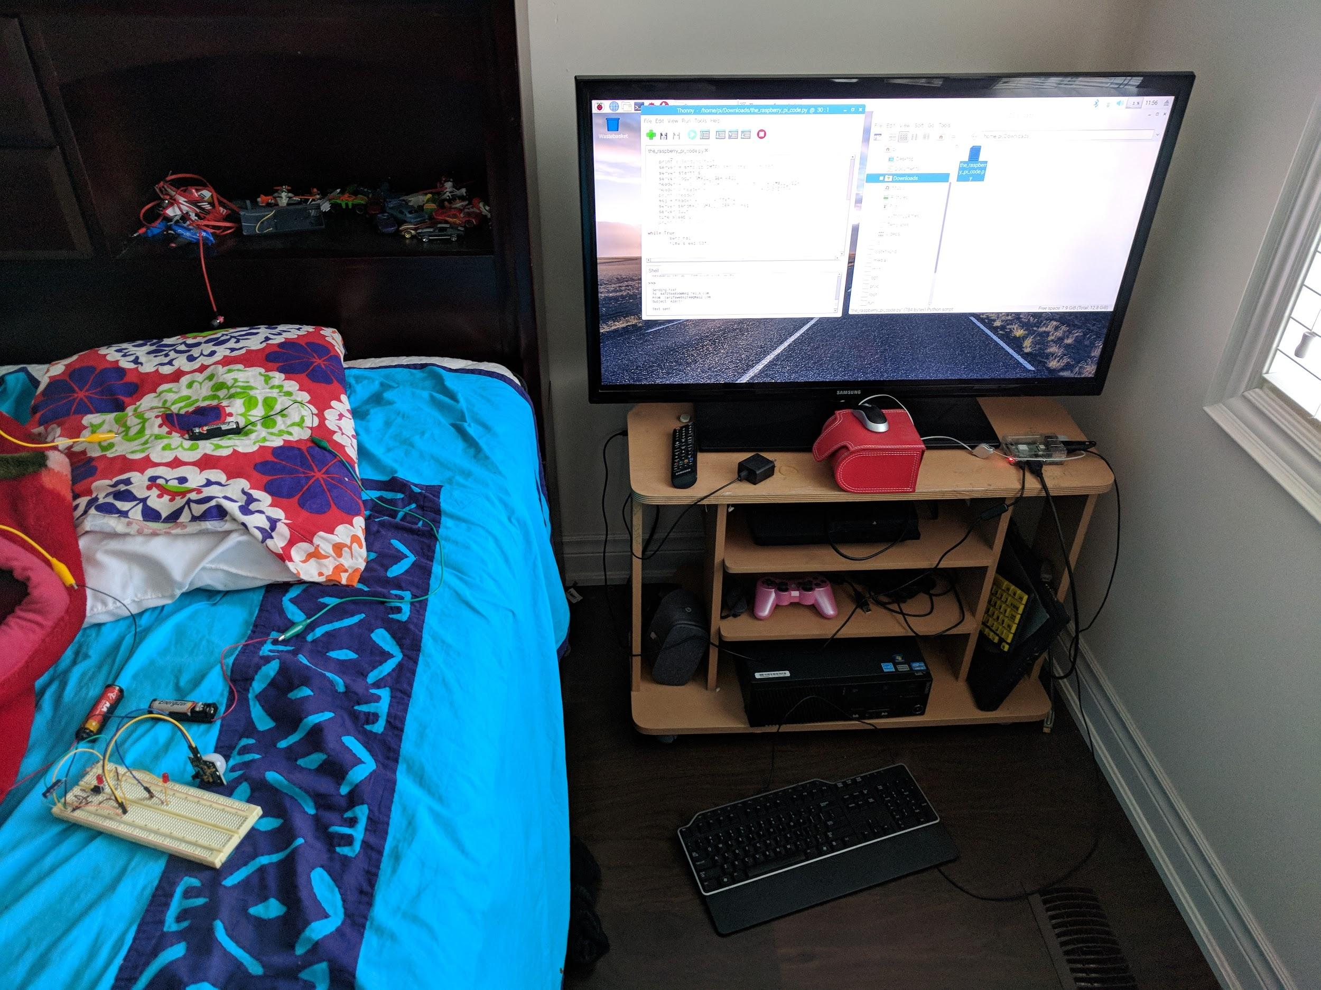

*By: Jarif Aftab*

*Mr. Knowles*

*TEJ3UO*

*June 14th, 2018*